***Welcome to***

**✞Holy Cross Church✞**

Parish Priest: **Fr. K. Lawrence**

128 16 Ave N. Creston B.C.

Office Tel. 250-428-2300

Office email: [holycross06@shaw.ca](mailto:holycross06@shaw.ca)

Office Hours: Tues.Thur, Fri. 9:30am - 12:30pm

**Holy Week Mass Times:**

* **Holy Thursday** April 6th 7:00pm
* **Stations of Cross** April 7th 11am
* **Good Friday** April 7th 3:00pm
* **Blessing of Bread** April 8th TBA
* **Easter Saturday** April 8th 7:30pm
* **Easter Sunday** April 9th 9:30am

**Annual general meeting**

**Sunday After Mass**

**Brunch by donation included**

**All parishioners strongly encouraged to attend!**

Fax. 250-428-4110

Hall Tel. 250-428-2271

**Website: holycrosscreston.com**

Mailing: Box 299, Creston B.C. V0B 1G0

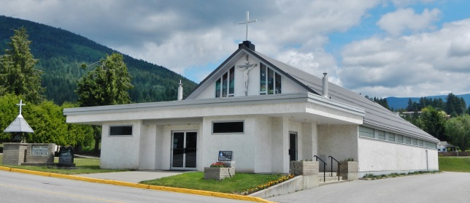

**Mass Times**

**Holy Cross Church**

Sunday - 9:30am

Monday – 9:00am

Tuesday - 9:00am

Wednesday - 9:00am

Thursday - 9:00am

Friday – Stations 6:30pm

Mass - 7:00pm

Saturday – 5:00pm

***Exposition of Blessed Sacrament*** –1st Sat & Sun of month 30 mins before Mass **AND 9am Fridays to 11:45 Divine Mercy Chaplet concludes Adoration @ 12.**

**Riondel Mission (MHR)**

No Mass Until End March

Parish Website:

[www.holycrosscreston.com](http://www.holycrosscreston.com)

**Sacraments**

***Reconciliation***

* Weekdays after 9:00am Mass
* Before Mass on Saturday and Sunday
* By appointment.

***Baptism or Marriage*** - Please make an appointment with Parish Priest.

***Sacrament of the Sick*** - Call the office or Parish Priest.

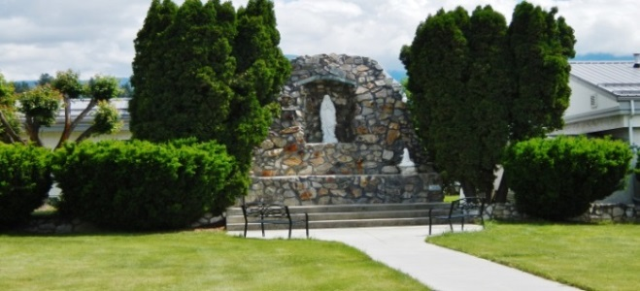

**Registration**

* **New to the Parish?**
* **Change of address?**

Please fill in the form below to register or change your present registration. Place in collection basket or return to the Parish Office.

Name_______________________

Address_____________________

City________________________

Postal Code__________________

Phone_______________________

Email_______________________

**Church Envelopes:** Would you like a box of envelopes? Numbered boxes identify the donor for income tax purposes. A tax receipt will be issued each year and sent to the address registered with the Parish.

Envelopes needed: 🞏 Yes 🞏 No

**Development & Peace**

**2nd collection today!**

**Welcome Home**



**To Our visitors, enjoy your visit with our parish family.**

**To our new parishioners,**

**Welcome Home!**

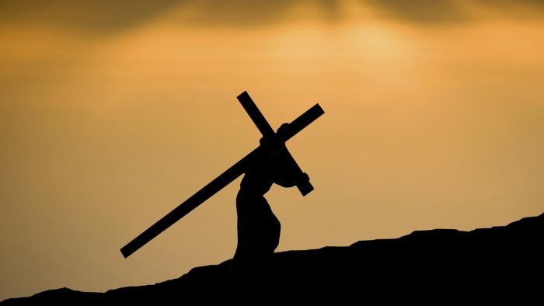

**Stations of the Cross**

Stations of the Cross **every Friday during Lent at 6:30pm,** followed by Holy Mass.

**March 26th, 2023, 5th Sunday of Lent**

*“I am the resurrection and the life, says the Lord; whoever believes in me will never die.”*

**Most Holy**

**Redeemer**

**Riondel**

**Mass Resumes**

**April 2023**

**Contacts: Christa Nagel: (250) 227-9355**

**Judy Bounds: Secretary: (250) 227-9575**

**Scott Angus: Treasurer: (250) 227-9458**

**May God’s Healing Love Enfold Those Who Are Sick:**

**Please Pray For the Sick in Our Parish :**

Mary Ann Staples, Chris Watson, Max Shramm, Dorothy, Marty Sontag, Antonia Kananowicz, Katherine Lemieux, Julia Jones, Anne Long, Cathy Salviulo, Rose Pompu, Marianne Knopfler, Kahlia, Sylvia Manning, Pauline Brezden, Ed Kulicki, Dianne, Wendy Lansing, Kelly McGovern, Michelle Romano.



**Parish News**

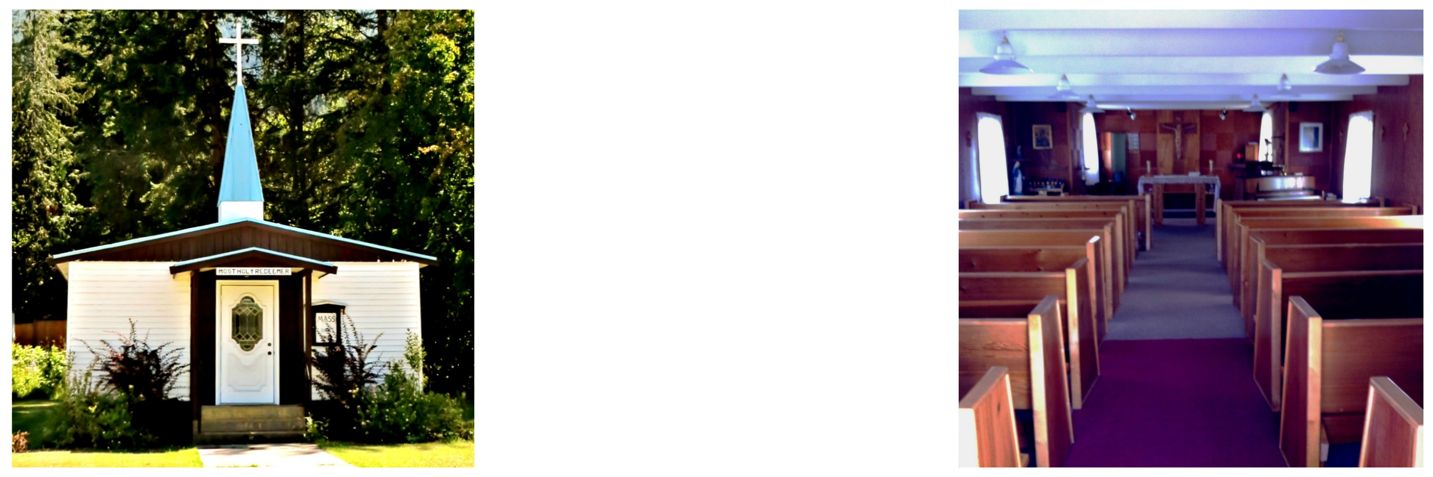

**Word of Life for March**

Live as children of light: for the fruit of the light is found in all that is good & right & true.

*(Eph. 5:8-9)*

true. (Eph. 5:8-9)

**Memorial Flowers**

Envelopes for donations for Memorial

Flowers for Easter are on the table in the vestibule.

In memory of…

*Mary, Allan & Shawn McLean & deceased members of Markey & McLean families*…………………….. Colleen Hedlund



**Our Lady of Guadalupe Pilgrimage**

*(see next pg for write up)*

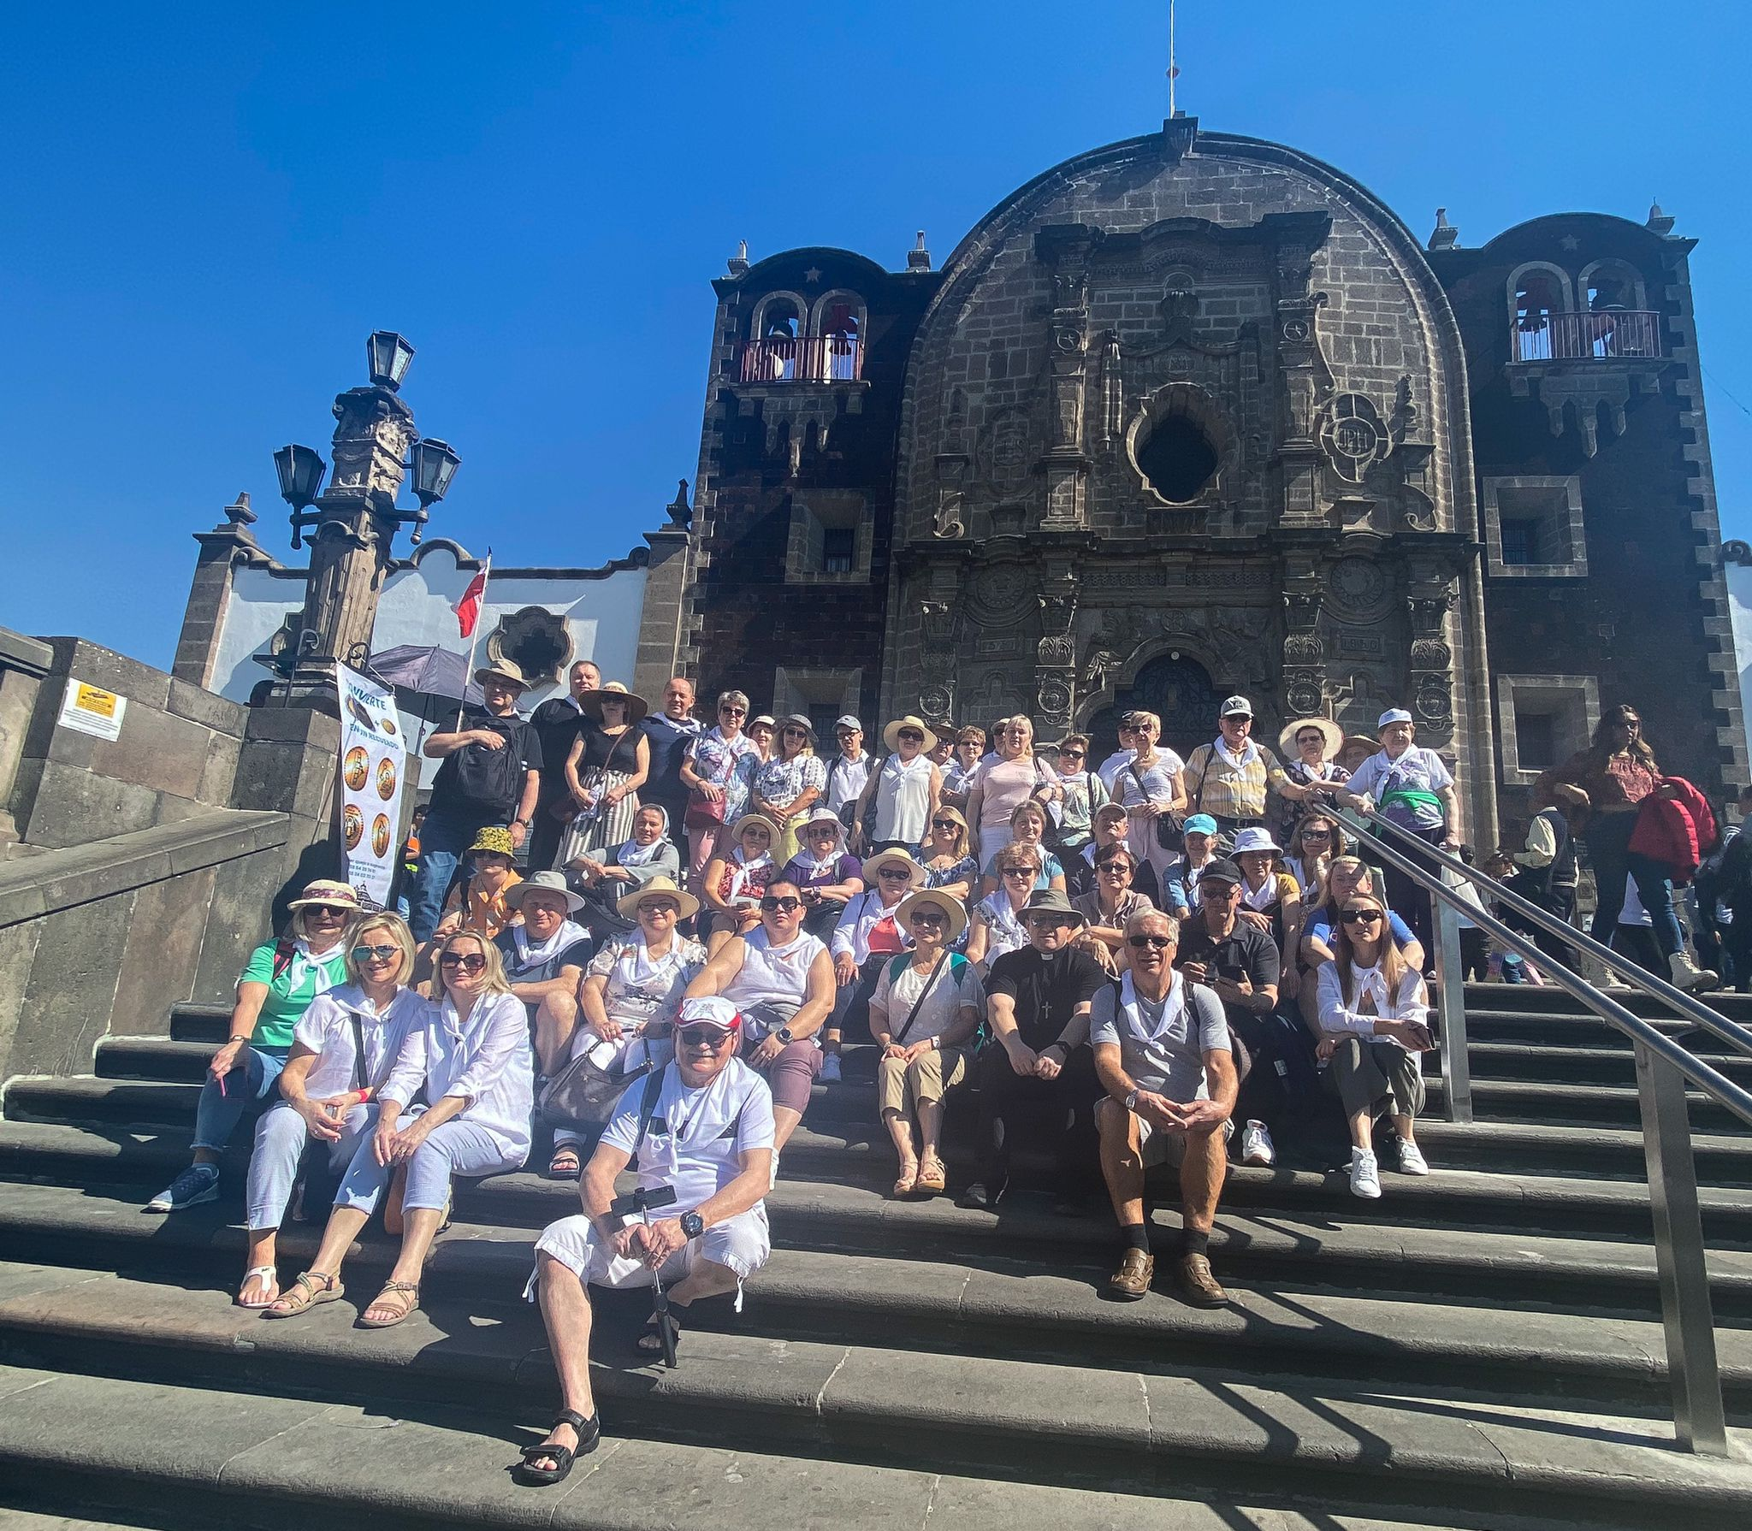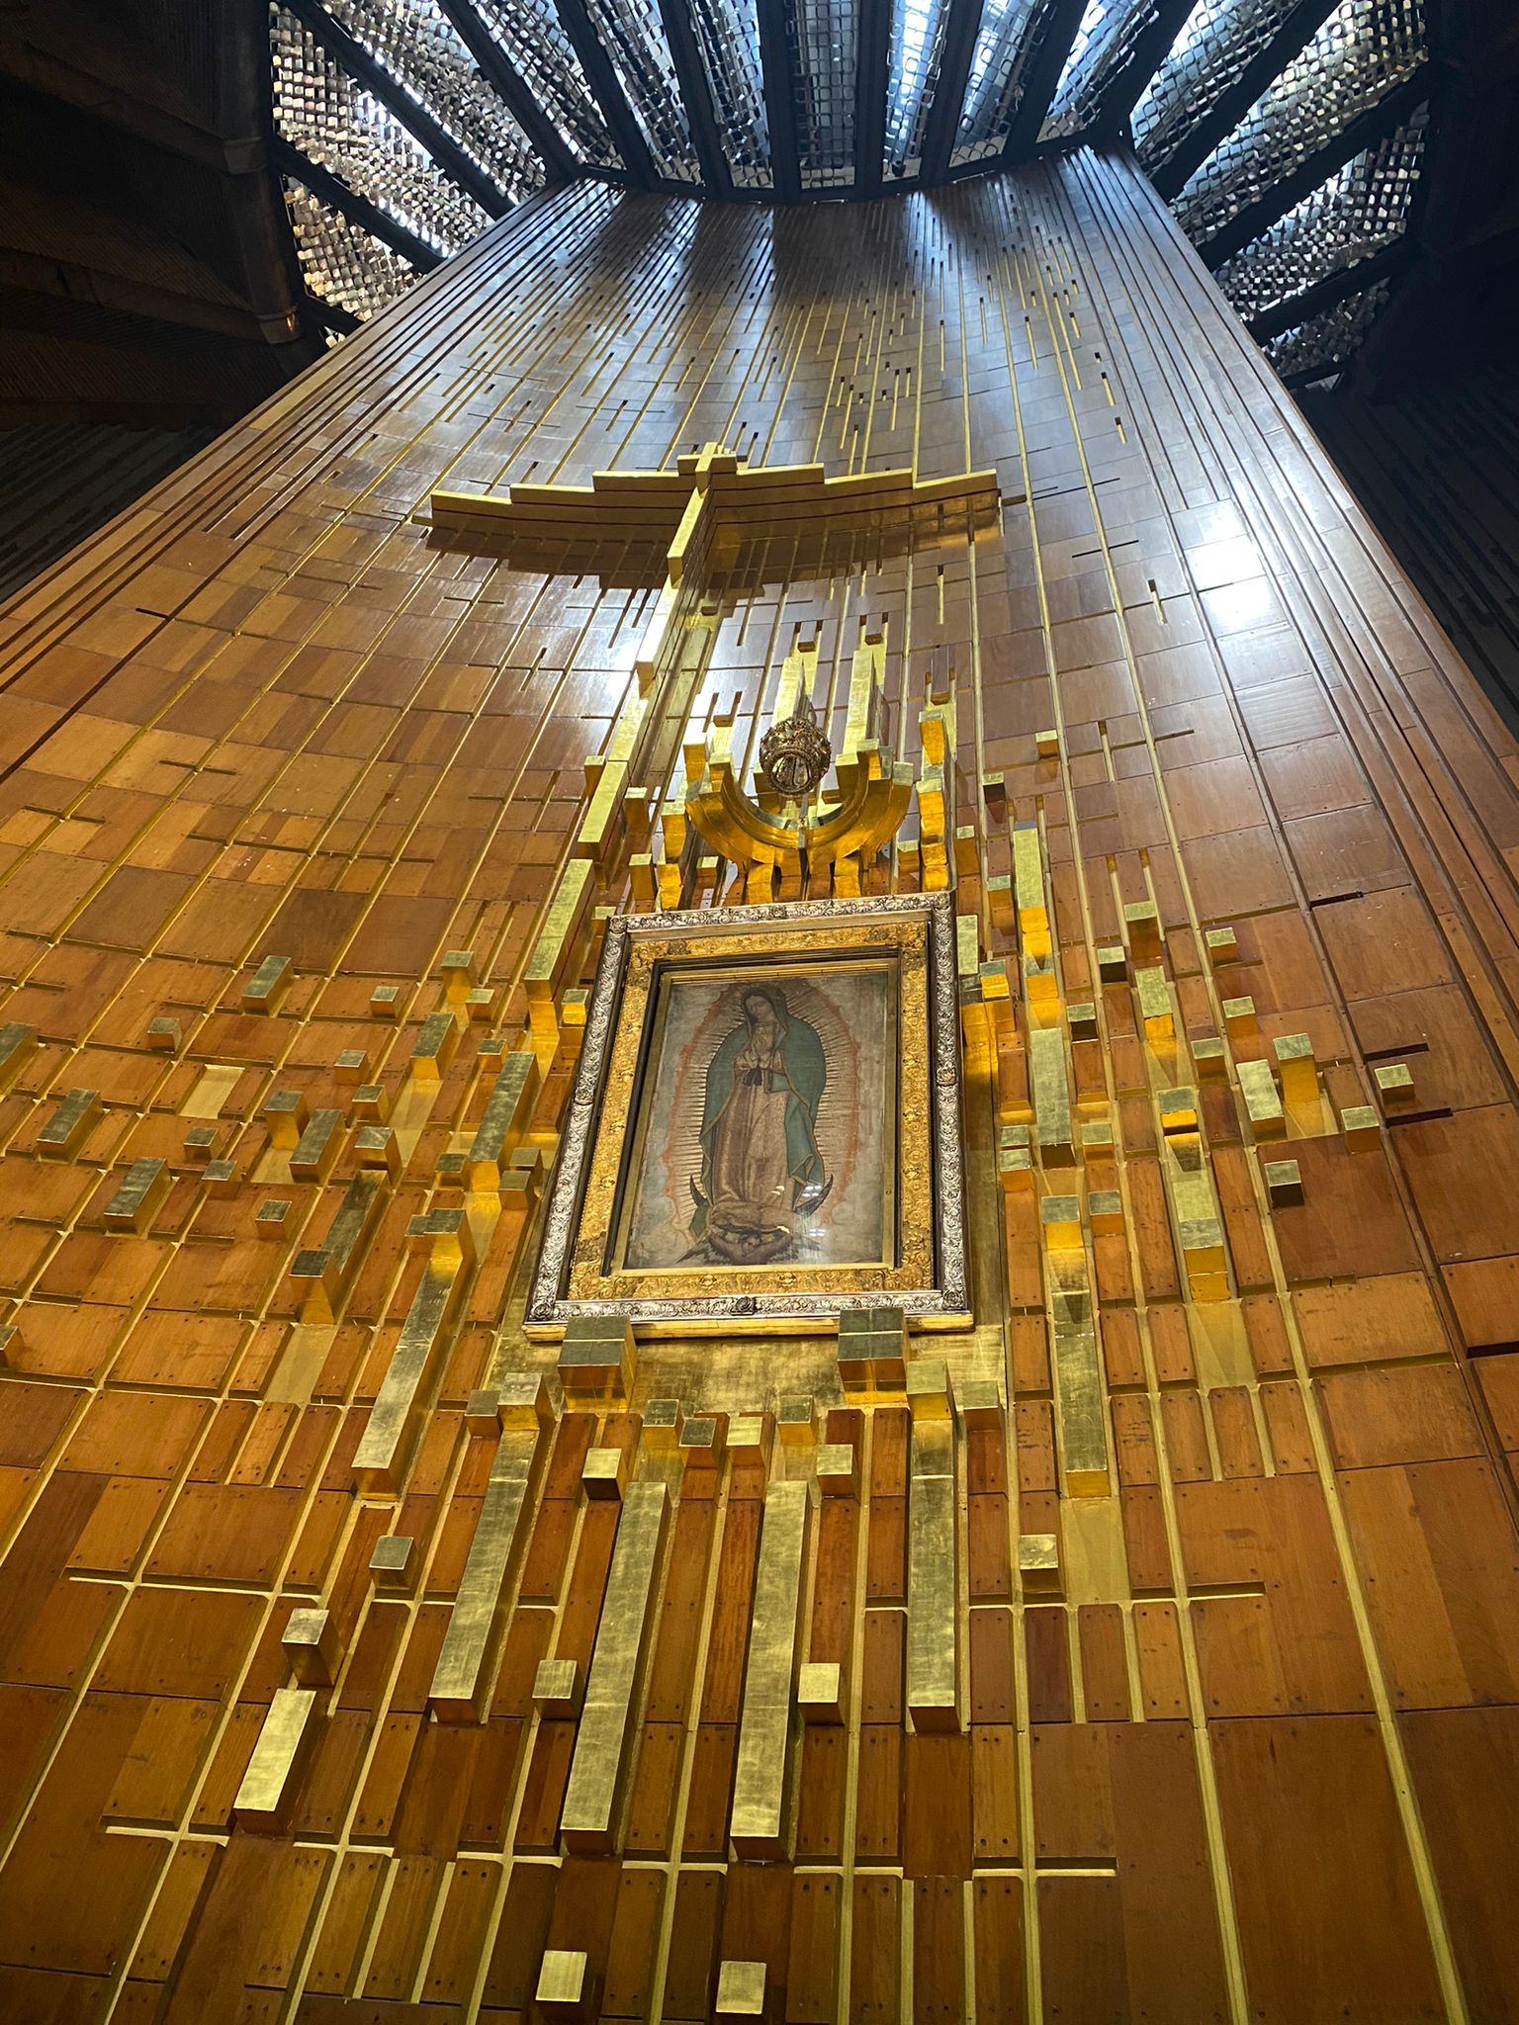

**Church Cleaning**

Please consider coming to help clean the church for Easter, on Saturday April 1st

@ 10:00am. THANK YOU!

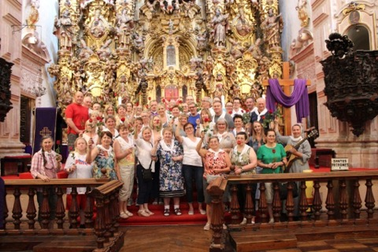

**Adoration During Lent**

There is Adoration every Friday

from **9am to noon** during Lent. Adoration concludes with

Divine Mercy

Chaplet at

11:45am-12pm

**ALL**

**WELCOME**

**ANYTIME!**

**…Being Good Stewards…**

***How grateful we are for your Sunday offerings last weekend,***

**Total Offerings:** *Mar 18th & Mar 19th* ***$1899.25***

*(Weekly amount needed to meet our Parish operational expenses:* ***$2650 -2019 budget****) Thank You!*

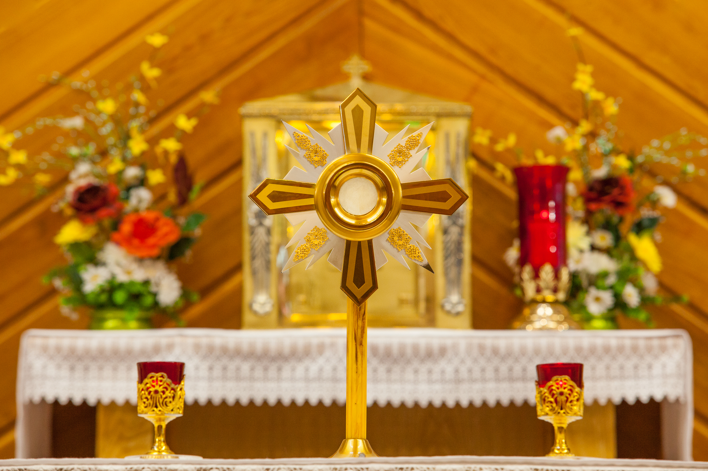

**Mass Schedule March 25th – April 2nd**

|  |  |  |  |  |  |
| --- | --- | --- | --- | --- | --- |
| **Sat** | **Mar 25**  **5:00pm** | **Healing of Kelly McGovern** (Mary & Ralph) | **Wed** | **Mar 29**  **9:00am** | **Mother Angelica, for her conversion** (Elmer & Irene) |
| **Sun** | **Mar 26**  **9:30am** | **Sp. Int. for all parishioners** | **Thurs** | **Mar 30**  **9:00am** | **Sp. Int. Vera & George** |
| **Mon** | **Mar 27**  **9:00am** | **Fr. Lawrence & all who prayed for me** (Pauline) | **Fri** | **Mar 31**  **7:00pm** | **Healing Steven vd Merwe** (Family) |
| **Tues** | **Mar 28**  **9:00am** | **Repose Christopher v/d Merwe** (Elmer & Irene) | **Sat** | **April 1**  **5:00pm** | **Sp. Int. Vigna Family** (Ralph & Mary) |

**A Visit to Our Lady of Guadalupe** *(Justyna Serniuk)*

A few days ago, I had the privilege of visiting the Shrine of Our Lady of Guadalupe in Mexico City on a pilgrimage with group from the Ontario Polish Catholic Church where my family and I used to attend. I would like to share my observations and reflections with you today.

During my visit to Our Lady of Guadalupe I kept asking myself what she does for me, for her followers? What is her message to people in today’s modern world?

I traveled to Mexico to pray for her guidance. And from that moment on, I began to educate myself about her. How she had appeared before an Indigenous man Juan Diego on December 9, 1531 identifying herself as the Virgin Mary, the Mother of the only true God.

And how she had selected him for his simplicity and humbleness to witness the miracles revealing her presence- and a mother’s unwavering love for all people.

Our Lady of Guadalupe could not have come to Mexico at a better time and with better message. She appeared a decade after the Spanish had conquered the Aztec empire. It was a dark time for the native population, their gods destroyed, and their culture trampled. The indigenous Mexican people were having a hard time understanding the religion the Spanish had just introduced to them. On the other hand, the Spanish were also having a hard time explaining their faith to the indigenous people. Language barriers, cultural and religious ignorance between them were contributing to the rising frustration. Just when things could not get any worse, Our Lady of Guadalupe came to the rescue, bridging the gap with her motherly love.

Also I would like to mention that the result of this singular miracle was nothing less than miraculous itself as the native Indians of Mexico began to convert to the One true Catholic Faith by the millions. Previously these people had suffered under the scourge of the Aztec religion, one of the bloodiest forms of paganism known to mankind.

Aren’t we now living in a painful fractured and insecure world that’s not that different from the era of the Spanish conquest?

There is so much darkness in people’s interiors. Faith is attacked, though for the most part not as blatantly or violently as at some points in history. In schools, social media and in culture God does not exist, or it is a fairy tale…

New generations grow up untied to their family values, their parents and grandparents’ faith. They grow up in fear, insecure about their present and future. What happened?

The only one that offers us a response is Our Lady of Guadalupe.

She is the only one who can sow hope and encourage us to keep moving forward, as she did nearly 500 years ago to a people who had lost the center of their life, their faith.

She reminds us that we should be treated with dignity, regardless of our situation in life, that we have an important role to play. She calls on us to have confidence in ourselves in our faith and in our God.

“AM I NOT HERE, I, WHO AM YOUR MOTHER”?

These words help us to have hope, faith and strength.

She walks with us, but also reaches out to all those who need her most, she continues to ask us to for the same: to love each person- the immigrant, the disabled, the poor, the orphan, the unemployed, those who are different, with faces reflecting stories of pain, joy, hope, those who we see during our daily routines.

Our response to this situation, how we approach it will depend on how we express ourselves as Christian followers of Christ.

By her image appearing on Juan Diego’s tilma, she linked her life, her heart, her soul, to our simple and humble people, demonstrating her presence among us, so then when we contemplate her, we hear her message:

AM I NOT HERE, I, WHO AM YOUR MOTHER?”

So the answer is simple : Our Lady of Guadalupe liberates us from within, giving us the confidence to go forth to face new worlds, knowing she will be tenderly at our side, encouraging us to move forward, and to entrust our fate to our only God.

I picture my family, my loved ones and the whole community wrapped in Mary’s mantle, covered in prayer and surrounded by love.

Thank you. Justyna Seniuk